In this assignment, I will cover and implement service discovery agent with two services which are registered to this agent. The discovery service will be implemented using Eureka-Server.

I have introduced a new project, with reference to Eureka-Server at the pom.xml file as suggested at the assignment detailed, set up an application.yaml file with suitable port, client, server and service-URL configurations. Then, I’ve implemented three interactable clients: Spring Discovery client, Rest Template client and Neflix Feign client.

I’ve also introduced the Docker’s run.sh files of the Asset & Organization services with the Eureka Service’s port, so they could register to the discovery service.

Running mvn clean package docker:build :

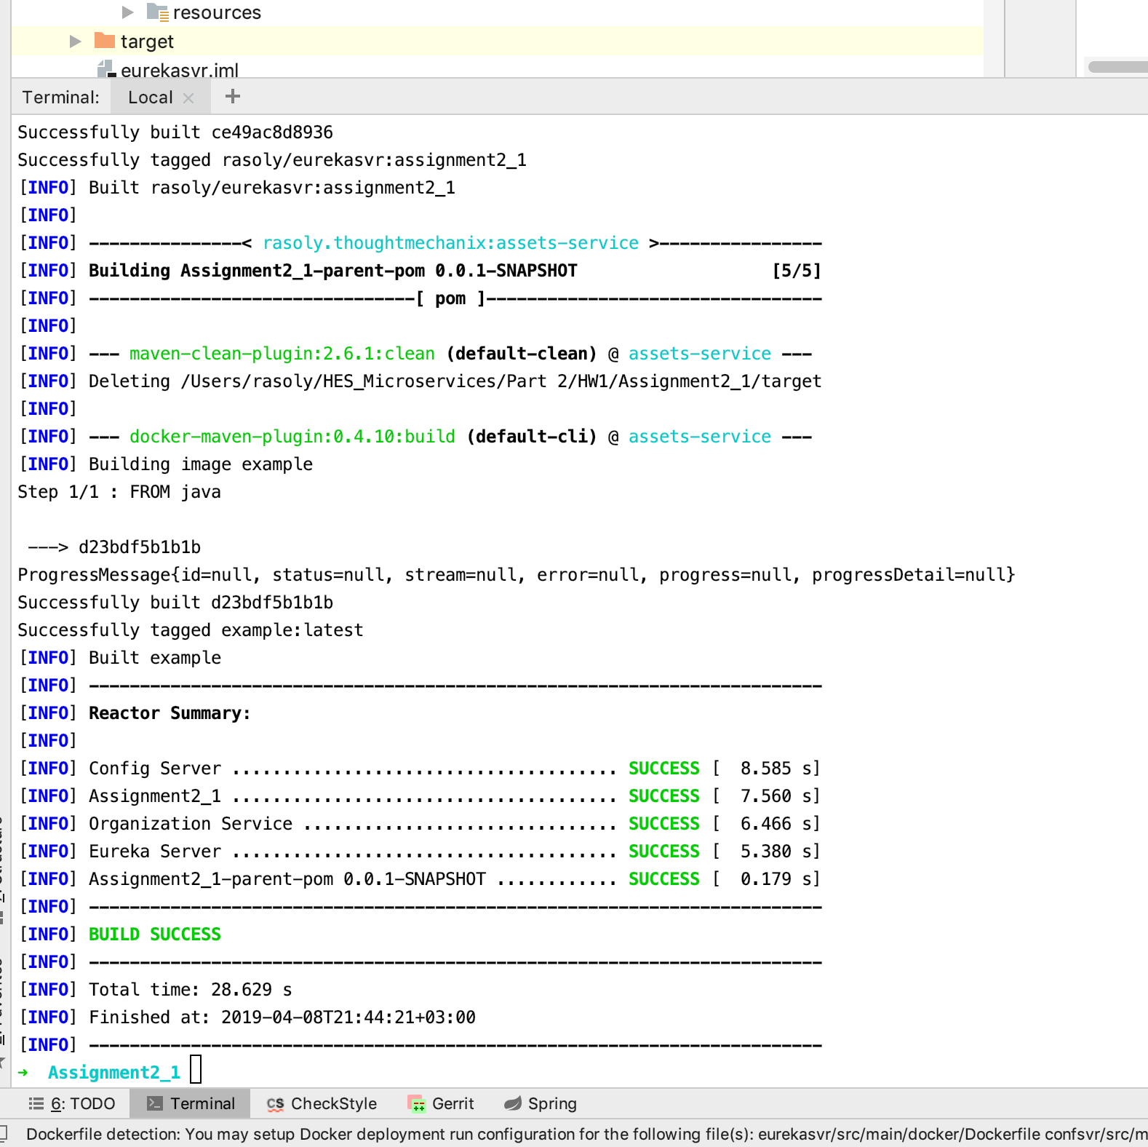

docker-compose -f docker/common/docker-compose.yml up :

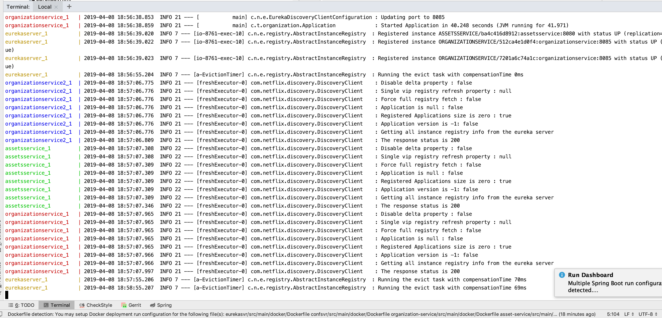

Calling organization service in the registry:

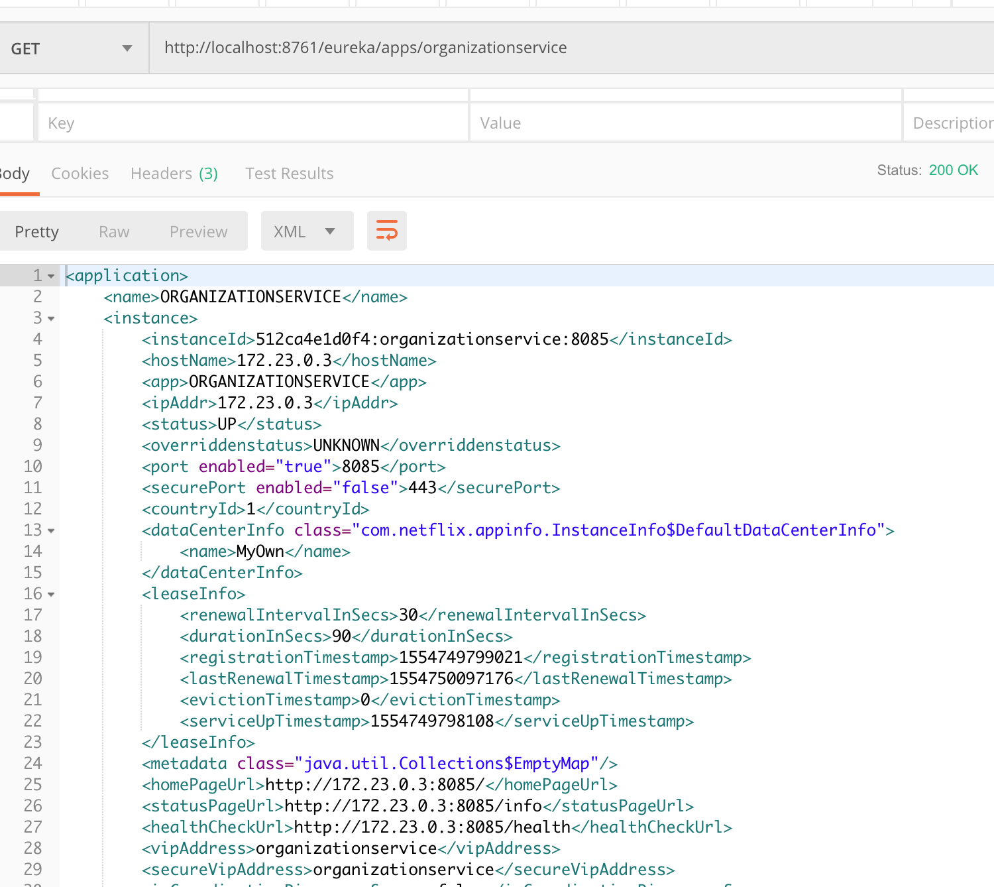

Calling asset service in the registry: 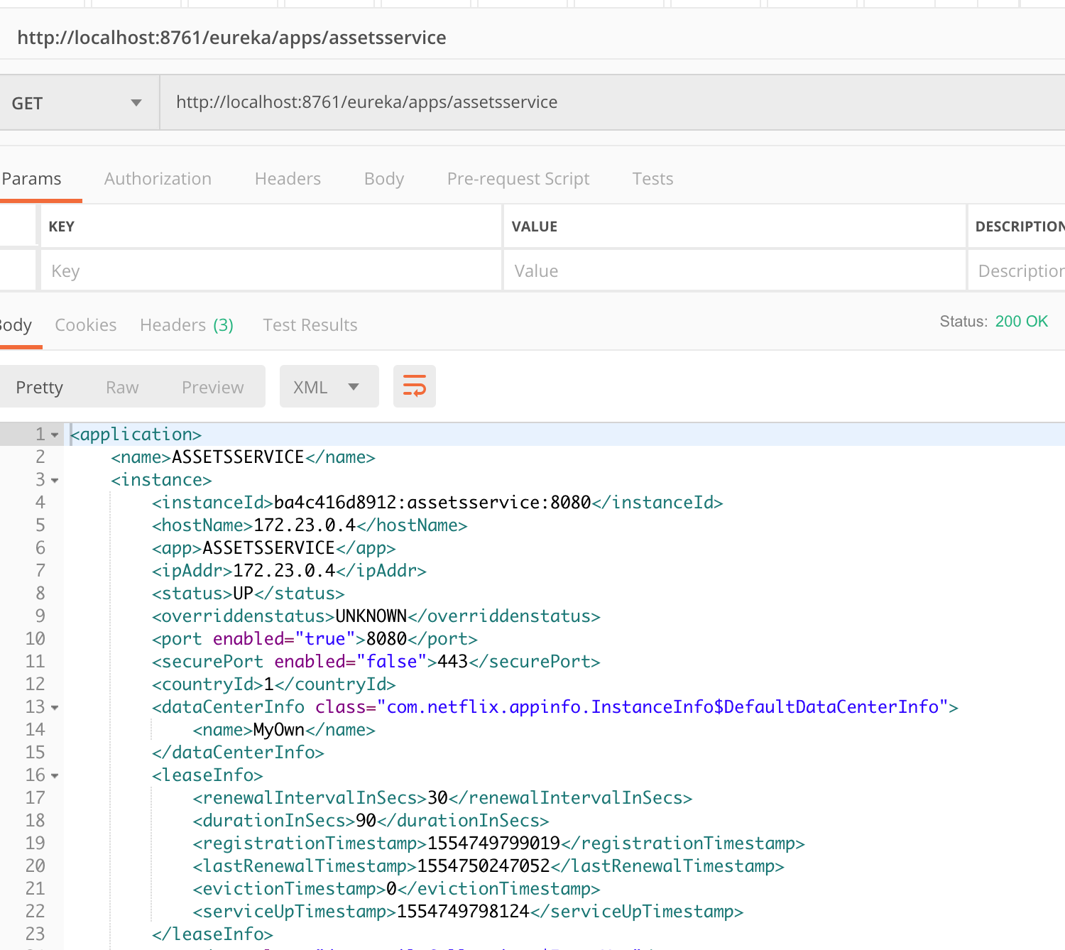

Getting assets of an organization using an ID from the schema.sql:

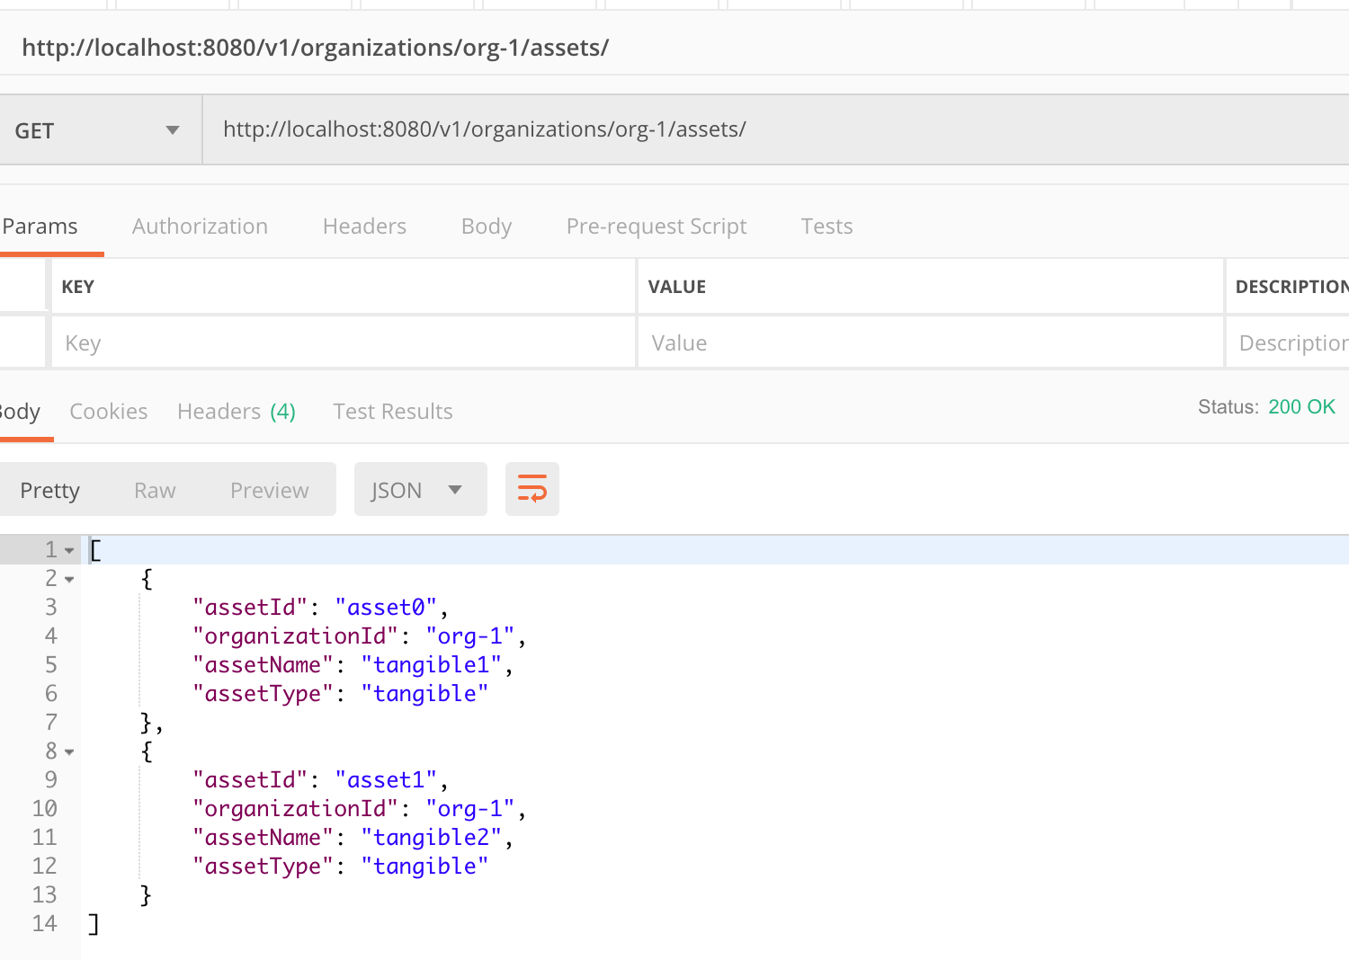

Getting a specific asset of the above organization id:

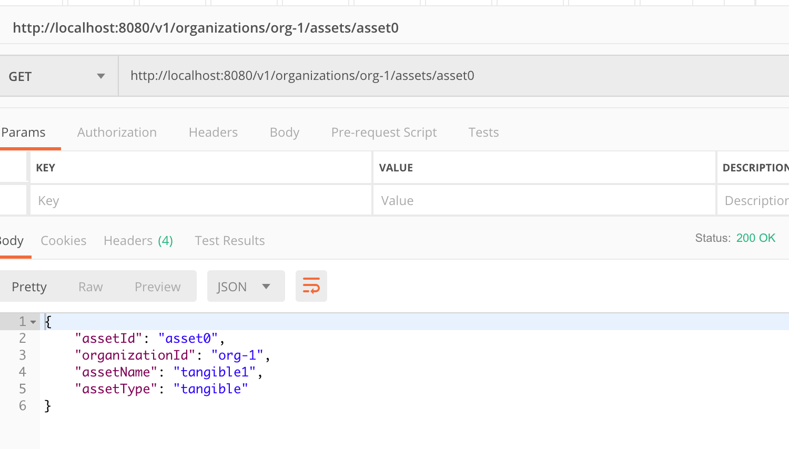

Information output about the above request :

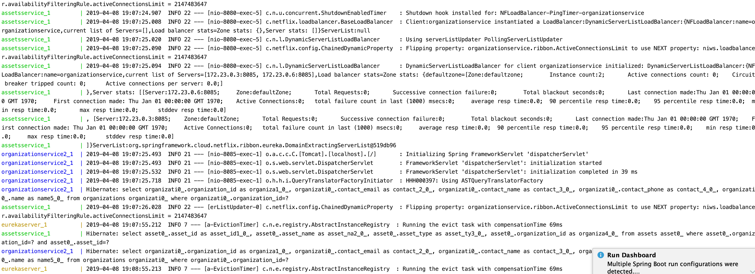

Same request, using Spring Discovery Client:

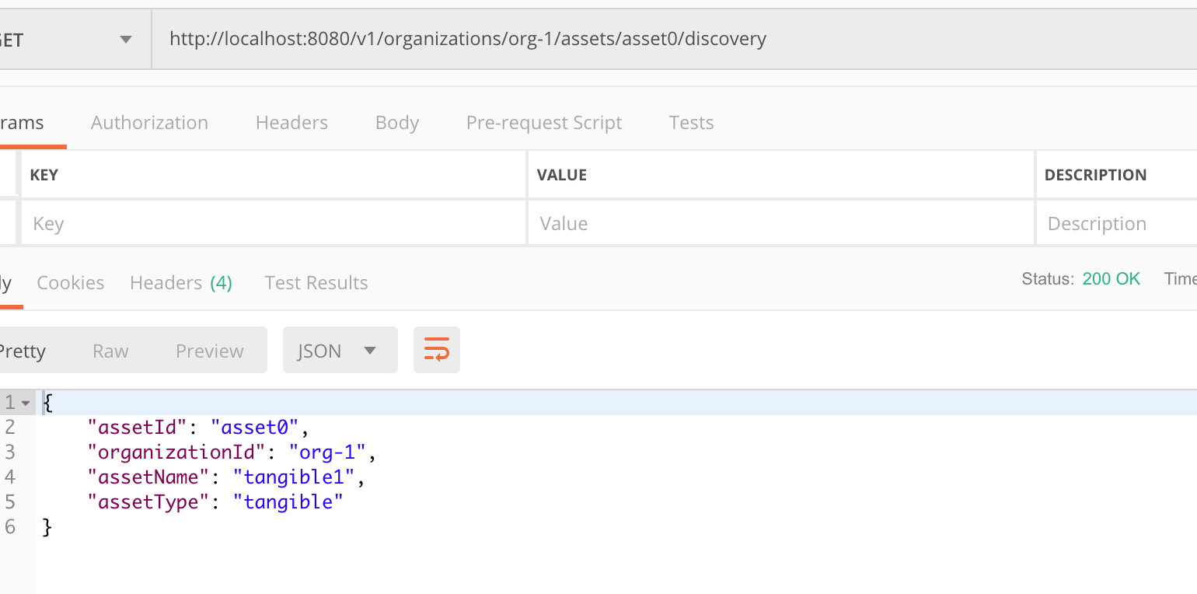

Output:

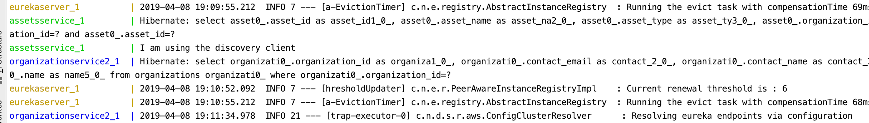

Same request, using Feign Client:

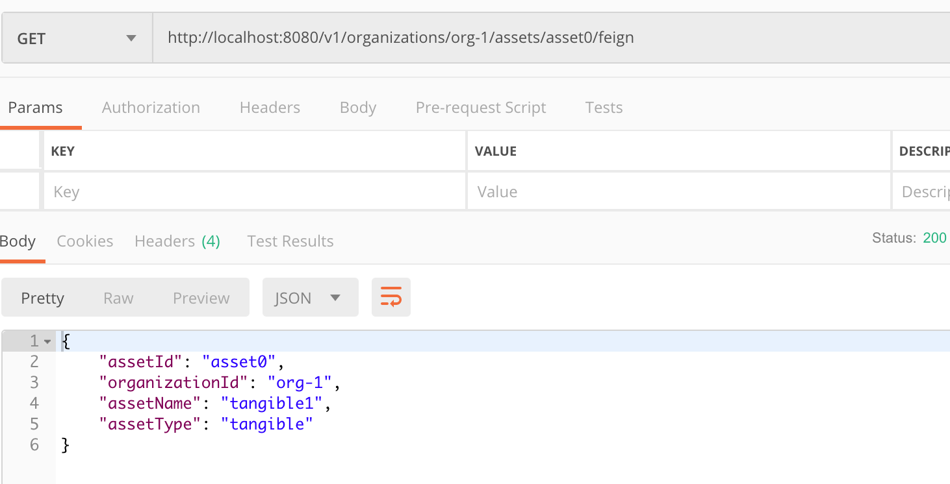

Output:

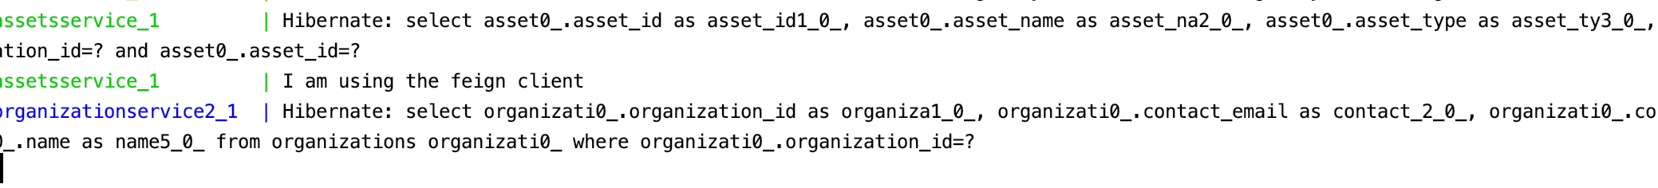

Same request, using RestTemplate client:

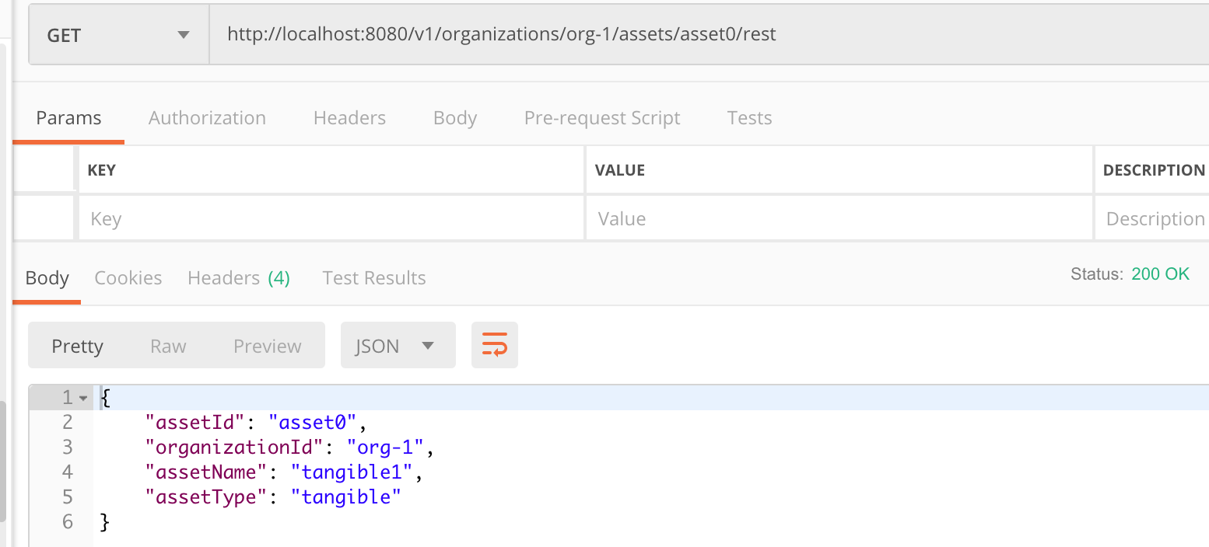

Output:

